Everett School Employee Benefit Trust
Trustees: Mike Gunn Susan Lindsey Molly Ringo Elizabeth Selders
David Jones, Chair John W. Morrill, Secretary

4730 Colby Avenue  Everett  WA  98203  Phone: (425) 385-4023  Fax: (425) 385-4022

September 14, 2011

To the benefit eligible employees of Everett Public Schools:

The Trustees of the Everett School Employee Benefit Trust recently shared with you information about some of the factors affecting our medical and dental plans, and how these factors will likely impact our future costs for benefits.

We are preparing to make decisions about our benefit plan offerings for next year, and are sharing the most recent information that we will be using to make these decisions about our benefits.

That was then:
For many years our history of employee benefit claims has been low, state funding levels increased regularly, and the Trust wisely built up financial reserves to help insulate us all from future cost increases. Our employee contribution rates have historically only required employees to cover an average of about 12 cents of each dollar of the actual costs for the medical and dental services they received. The Trust has been able to subsidize the remaining 88 cents of each dollar. This situation has changed.

This is now:
- We are using more of our health benefits than in the past, and the services are more complex than we have traditionally experienced. These two trends drive up the rates when we ask insurance companies to bid on our health coverage. One influence on usage is our average age. Our workforce is getting older. Over the last three years the medical risks (and associated costs) attributed directly to our increased average age has accounted for a 6% increase in the cost of our coverage.
- On top of the cost increases driven by our higher average age is the continually increasing cost for health care that everyone in our nation is experiencing. As employees of Everett Public Schools we are not isolated from these nation-wide trends in cost increases.
- State funding for medical and dental benefits has not kept up with the actual rise in cost for these plans. Funding levels are currently frozen for the 2012 and 2013 calendar years. What has been inadequate funding has become inadequate funding frozen at a low level while costs continue to rise.
- Because the Trust wisely built up reserves, there has been funding available to us over the last 5 or 6 years to help offset increased costs and to smooth out spikes in year-to-year rate increases. Our reserves have been drawn down to the point where funds are no longer available to provide this support. The only sources currently available to fund benefits are employee contributions and the frozen level of state contribution.
- With increasing insurance costs and flat state funding, cost increases will have to be covered by increasing the amount that each of us pays each month for our coverage. This increase could result in employee contribution rates that are many times higher than current rates and may result in much higher co-payment and deductable limits.
- Having to pay more each month and then having to deal with higher co-pays and deductable levels will be a big hit for all of us. In response, the Trust is also considering ways to reduce or restructure the existing benefit plan designs as a way to lower the huge cost increases.

Some of you may wonder about the status of the Wellness program and the impact that this has on our benefit expenses. The Wellness program has been a contributing factor in containing health care costs and many employees have been positively impacted. From a budget perspective, Wellness program costs are less than 1% of the Trust’s budget. The elimination of the Wellness program would not significantly alter the status of benefit coverage for 2012.

Please read the attached article to learn more about what is happening in the market around benefit plan design changes and employee contribution increases. As your Trustees, we have been following this news, knowing that what is happening outside of our influence may negatively impact the benefit plans and rate structures that we have worked so hard for so long to preserve for the employees of Everett Public Schools.

As always, we are committed to offering you the best and most sustainable benefit plans and rate structures possible.

Sincerely,

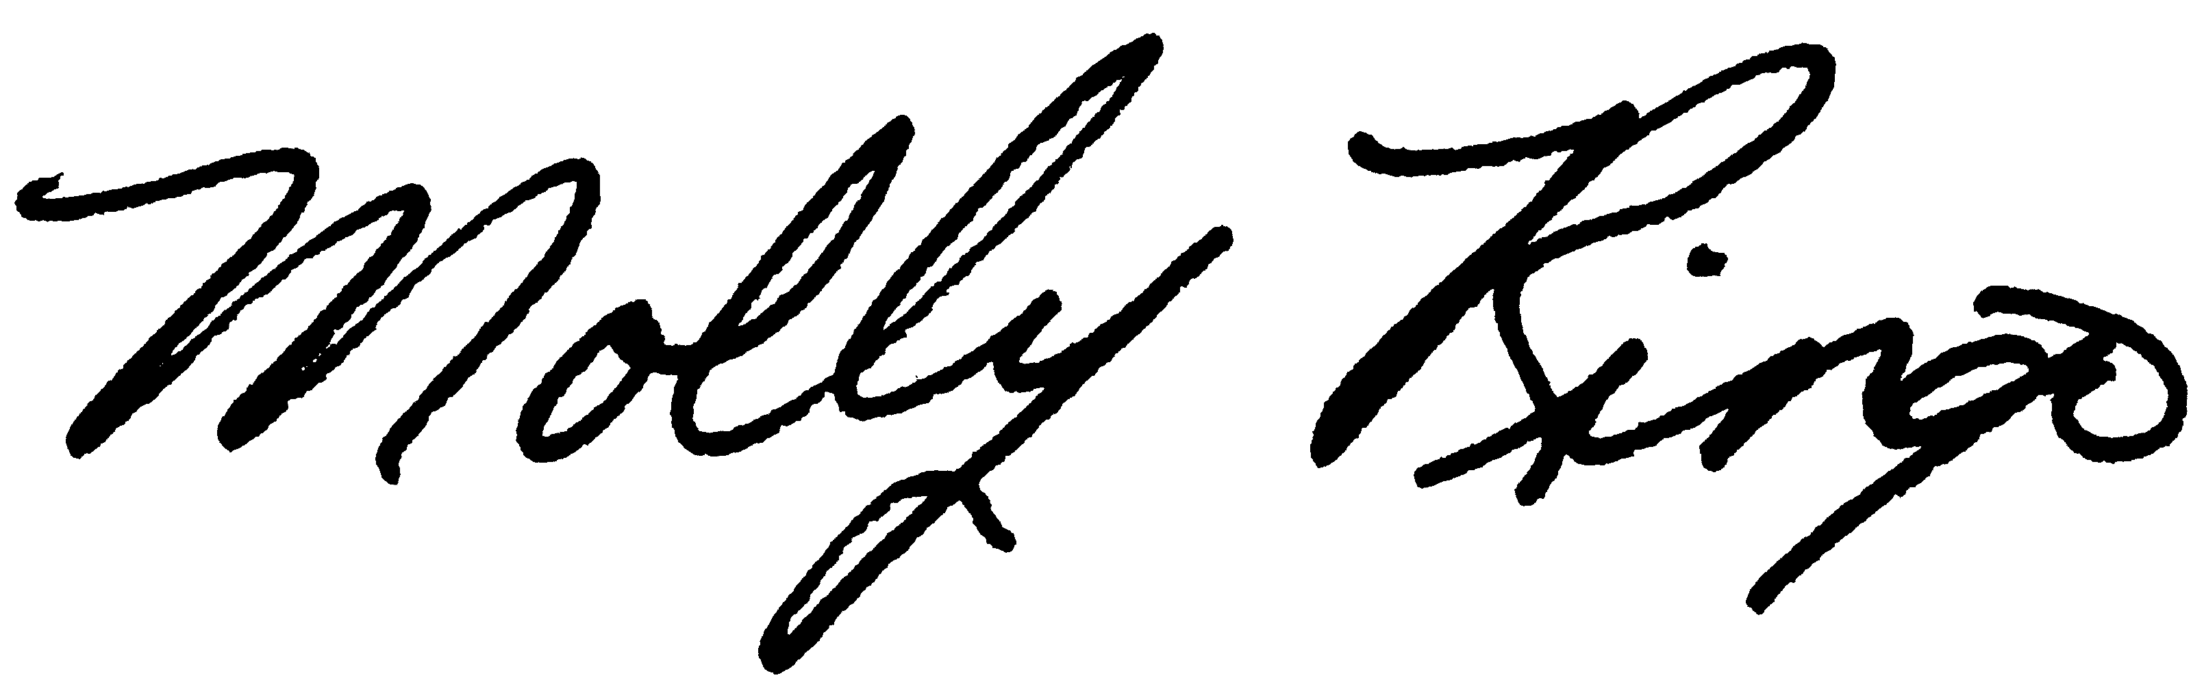
The Trustees of the Everett School Employee Benefit Trust

Enclosure

